**Project Design Phase-II**

**Data Flow Diagram & User Stories**

|  |  |
| --- | --- |
| Date | 4 June 2025 |
| Team ID | LTVIP2025TMID38618 |
| Project Name | Revolutionizing Liver Care : Predicting Liver Cirrhosis using Advanced Machine Learning Techniques |
| Maximum Marks | 4 Marks |

**Data Flow Diagrams:**

A Data Flow Diagram (DFD) is a traditional visual representation of the information flows within a system. A neat and clear DFD can depict the right amount of the system requirement graphically. It shows how data enters and leaves the system, what changes the information, and where data is stored.The below figure represents the a streamlined workflow of how machine learning is applied in a clinical setting to predict liver cirrhosis. It begins with patient data and a medical dataset, which are accessed by a clinician or user. The data undergoes preprocessing before being passed through machine learning models such as Naive Bayes, SVM, and Random Forest. These models analyze the data and generate a prediction along with a confidence score. The final output is displayed to the user, providing an accurate and efficient decision-support tool for early detection of liver cirrhosis.

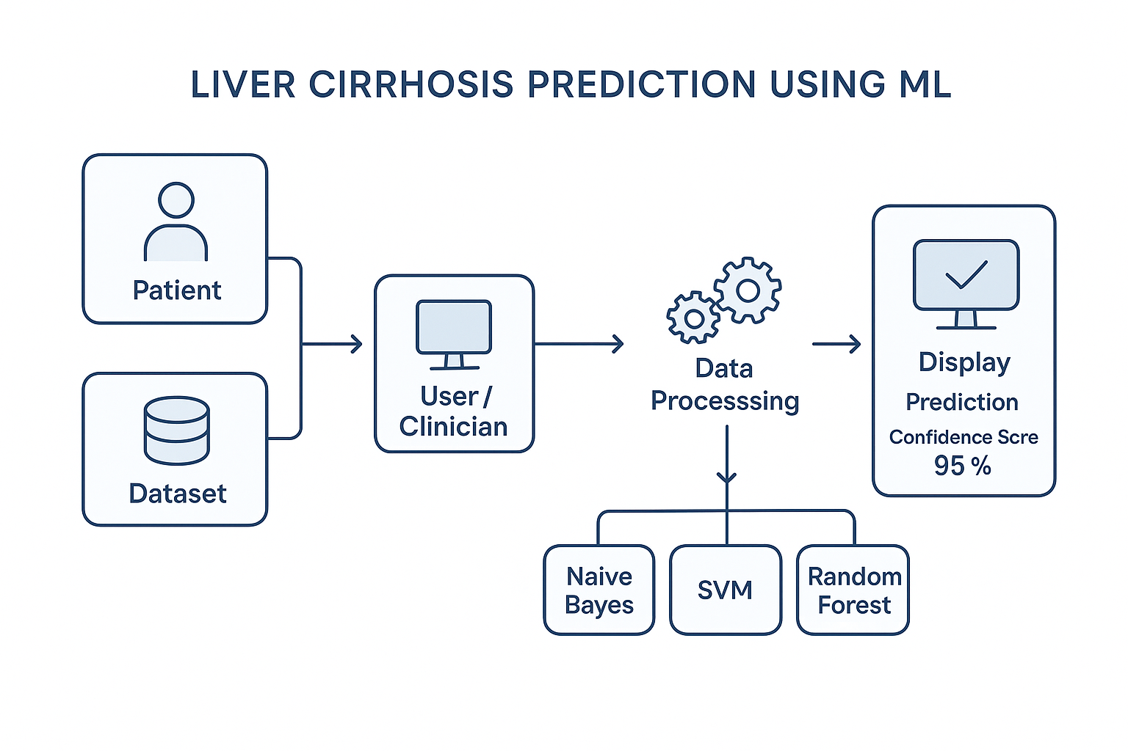

**User Stories**

The functional expectations of the system from the perspective of its users—clinicians and developers. Each user story defines a specific task or goal, ensuring the system meets real-world needs. The stories are categorized by functionality such as data upload, prediction, evaluation, and reporting, with associated priorities and sprint planning. This user-centered approach helps guide development and ensures all critical features are addressed efficiently.

| **User Type** | **Functional Requirement (Epic)** | **User Story Number** | **User Story / Task** | **Acceptance criteria** | **Priority** | **Release** |
| --- | --- | --- | --- | --- | --- | --- |
| Clinician/User | Data Upload | USN-1 | As a clinician, I want to upload patient clinical data to predict liver cirrhosis. | The system accepts and displays input data | High | Sprint-1 |
| Clinician/User | Prediction | USN-2 | As a clinician, I want to receive a prediction result based on input data | Model returns prediction (Yes/No) on liver cirrhosis risk | High | Sprint-2 |
| Clinician/User | Result Display | USN-3 | As a clinician, I want to view prediction results and confidence scores. | Accuracy/confidence is shown after prediction | Medium | Sprint-2 |
| Clinician/User | Report Download | USN-4 | As a clinician, I want to download the result as a report (PDF/DOCX) | Report gets downloaded successfully with prediction details | Medium | Sprint-3 |
| Developer/Team | Model Evaluation | USN-5 | As a developer, I want to evaluate ML models using performance metrics. | Metrics like accuracy, recall, precision are generated | High | Sprint-2 |
| Developer/Team | GitHub Documentation | USN-6 | As a developer, I want to document and upload the project to GitHub. | GitHub repo contains code, README, and model files | High | Sprint-3 |